

CMP6200/DIG6200

Individual Undergraduate Project 2024–2025

**A3: Dissertation**

Design and implement a digital game for upper limb exercises with haptic control to aid stroke rehabilitation.



Course:

Student Name:

Student Number:

Supervisor Name:

**Overall Note**

**Guidance Sections**: All guidance text is placed in green boxes like this one. Please ensure that you **remove these sections** before submitting your final document.

**Template Usage**: This document serves as a **general template** designed for common final year project purposes.

**Customisation**: It is crucial to tailor this template to fit the specific needs of your individual project. Discuss the structure and content with your **supervisor** to ensure it aligns with your project's unique requirements.

**Assessment Criteria**: Please refer to the marking criteria outlined in the **assessment brief** for more detailed information on how your submission will be evaluated. You do **NOT need** to include all sections to pass this assessment.

Abstract

A summary of the report (100-300 words), which should fully encapsulate the content of the project, while being informative, interesting and contain appropriate quantitative aspects (e.g., results). It should describe the project in one paragraph to follow introduction, method, results and conclusion. An example is provided below.

**Example:**

Automated drum transcription (ADT) systems attempt to generate a symbolic music notation for percussive instruments in audio recordings. Neural networks have already been shown to perform well in fields related to ADT such as source separation and onset detection due to their utilisation of time-series data in classification. An ADT system based on neural networks is proposed in order to exploit their ability to capture a complex configuration of features associated with individual or combined drum classes. In this paper, a bi-directional recurrent neural network is proposed for offline detection of percussive onsets from specified drum classes and a recurrent neural network suitable for online operation. In both systems, a separate network is trained to identify onsets for each drum class under observation—that is, kick drum, snare drum, hi-hats, and combinations thereof. Four evaluations are performed utilising the IDMT-SMT-Drums and ENST minus one datasets, which cover solo percussion and polyphonic audio respectively. The results demonstrate the effectiveness of the presented methods for solo percussion and a capacity for identifying snare drums, which are historically the most difficult drum class to detect.

Acknowledgements

Identifying those from whom assistance has been received. Use discretion in selecting the most relevant people who have directly helped or influenced the project completion.

**Example:**

First and foremost, I would like to thank my advisor, Prof. Charles Xavier, for his supervision throughout the course of my doctoral studies at Birmingham City University. Prof. Xavier has tirelessly provided his encouragement and guidance, which has helped me to define my research goals and to shape the scope and focus of this dissertation. His suggestions and careful critique during all stages of this dissertation were indispensible to the creation of this document. In this regard, I would also like to thank Dr. Jean Grey for her detailed reading and guidance towards a more cohesive, structurally-sound work. I very much appreciate the thoughtful reading and suggestions for improvements and future work provided by Dr. Hank McCoy, Piotr Rasputin, and Ororo Munroe.

For information about how to create a table of contents, creating styles, and page numbering and section breaks contact the [Learning Centre](https://www.bcu.ac.uk/computing/student-experience/student-support/libraries-and-learning-centres).

Table of Contents

Abstract ii

Acknowledgements iii

Glossary vi

List of Figures vii

List of Tables viii

1 Introduction 1

1.1 Problem Definition 1

1.2 Scope 1

1.3 Rationale 1

1.4 Project Aim and Objectives 1

1.5 Background Information 1

2 Literature Review 2

3 Method and Implementation 3

4 Evaluation 4

4.1 Evaluation Methodology 4

4.1.1 Evaluation Metrics 4

4.1.2 Baseline systems 4

4.1.3 Dataset 4

4.2 Results 4

4.3 Discussion 5

5 Conclusions 6

6 Recommendations for future work 7

7 References 8

8 Bibliography 9

9 Appendices 10

9.1 Appendix A: Dissertation Style and Conventions 10

9.2 Appendix B: Fonts, Paragraphs and Line Spacing 11

9.3 Appendix C: Mathematical Symbols 11

9.4 Appendix D: Figure and Table Captions 11

9.5 Appendix E: Text Headings 12

9.6 Appendix F: Pagination 12

Glossary

An ordered list of symbols and abbreviations with expansions of any contractions.

When creating the glossary, it is best to insert a table and then remove the borders. This will make the glossary look neatly organised.

Example:

|  |  |
| --- | --- |
| E&OE | Errors and Omissions Excepted |
| RAD | Rapid Application Development |
| SAD | Systems Analysis and Design |
| SDLC | Systems Development Lifecycle |
| XML | Extensible Mark-up Language |

List of Figures

When creating the List of Figures, it is best to insert a table and then remove the borders. This keeps the lists neatly organised. Word features (references tab) can also be used to automatically maintain such lists. Microsoft provides an [online resource](https://support.microsoft.com/en-us/office/insert-a-table-of-figures-c5ea59c5-487c-4fb2-bd48-e34dd57f0ec1) for this purpose.

**Example:**

Figure 2.1: Theory of charge pump design…………………………………………………….. 4

Figure 2.2: The MP3 Jukebox…………………………………………………………………… 5

Figure 3.1: A block diagram of the system architecture…………………………………...…. 7

Figure 3.2: The PSU utilising charge pump design………………………………………..… 13

Figure 4.1: The circuit diagram for the LCD display…………………………………………. 14

List of Tables

When creating the List of Tables, it is best to insert a table and then remove the borders. This keeps the lists neatly organised. Word features (references tab) can also be used to automatically maintain such lists. Microsoft provides an [online resource](https://support.microsoft.com/en-us/office/insert-a-table-of-figures-c5ea59c5-487c-4fb2-bd48-e34dd57f0ec1) for this purpose.

**Example:**

Table 3.1: Cell architectures…....……………………………………………………………….. 4

Table 3.2: Systems under evaluation..……………………………….………………………… 5

Table 3.1: Overview of previously proposed methods for ADT..………….……………...…. 7

Table 4.1: Parameter tuning variables and ranges …………………...…………………..… 13

Table 4.2: Mean F-measure results for semi-automatic evaluation ….……………………. 14

# Introduction

Upper limb stroke rehabilitation typically sees heightened implementation after patients are discharged from the hospital. After returning home a patient should undertake home therapy programmes to further recover and better their quality of life.

Having a range of home therapy options is vital, crucially due to patient travel limitations. Almost 10 million people in England live in rural areas. (Gov.Uk, 2024:7) In these areas there are more people aged 50-59 years than any other age group with one in four people being over 65 (Gov.Uk, 2024:8). This correlates with the ages statistically vulnerable to having a stroke. According to the GRASP instructor manual (The University of British Columbia, 2021:9) the risk of stroke doubles every 10 years after age 55, with the typical age at the time of stroke being 70 – 75 and 25% of strokes occurring in individuals below the age of 65.

The brain has the most ability to repair itself in the first 3 months’ post stroke (The University of British Columbia: 2021: 5) therefore it is vital that the patient completes as much therapy in this time as possible to maximise recovery. Currently there are home therapy programmes such as the GRASP manual. However contemporary home therapy programmes do not provide high levels of motivation to the patient, this can cause the therapy to be neglected leading to sub-optimal recovery or potentially other implications such as learned non-use syndrome (The University of British Columbia, 2021: 13).

Therefore, it is important to explore ways to provide more motivation to the patient. Gamification and even more so multiplayer gamification is one such way this goal can be achieved. Being able to play the game alongside family members, friends or caregivers may provide higher levels of motivation and reduce the neglect of home therapy, increasing its effectiveness.

This paper is the first stage of the experiment and will be tested on healthy adults to verify the intended movements are being performed in the correct repetition ranges and to test the user experience and motivation using the game.

## Problem Definition

A statement of the problem, with its significance and origin. If applicable, make reference to the company or industry that led to the project definition.

## Scope

This section identifies the boundaries of the project, what was included and what was excluded from the final project. This should be justified and underpinned by research.

## Rationale

Why has the topic been chosen? This may be because of lack of research in the area, to shed more ideas and opinion, in response to a request, (e.g., from a company, organisation or relevant current issue). What benefits can be identified from completing the project? This should be more than personal interest—you should be able to identify a company, organisation or other defined group that will benefit from the work.

## Project Aim and Objectives

### Project Aim

**The aim of this project is to produce a multiplayer game, utilizing etee controllers, which encourages movements beneficial to Upper Limb (UL) stroke rehabilitation and provides more motivation than conventional home therapy treatments.**

### Project Objectives

|  |  |
| --- | --- |
| **Objective Number** | **Objective** |
| **1** | **Identify characteristics of effective rehabilitation treatments.** |
| **2** | **Identify movements beneficial to providing effective rehabilitation treatment.** |
| **3** | **Use knowledge gained from objectives 1 and 2 to design, scope and plan the development of the game** |
| **4** | **Develop the game using the designs and plans produced in the previous objective using agile project management techniques** |
| 5 | Test the game with a group of adults to observe the repetitions of the intended motions and motivation to play the game relative to other therapy options. |
| 6 | Use the knowledge learned from testing to evaluate the projects outcomes. |
| 7 | Summarize and report writing |

## Background Information

A further section of background information will depend on the topic area of the project, but could include hypotheses and theory, which are to be tested in the course of undertaking the project. This is an optional subsection but may be useful in defining the contextual information.

# Literature Review

This should be derived from the literature review report.

It will **likely have been updated throughout the year**, including additional information of relevance arising through project completion and supervisor feedback. It will detail the knowledge gained of subject fundamentals and offer evidence to demonstrate that you have achieved a foundation of knowledge in your chosen subject area. Concepts, theories and opinions need to be critically evaluated and the reasons for application of the concepts and their relevance to the solution of the problem need to be established.

**Using the text from your A1/A2 submission will NOT be considered as self-plagiarism.**

### Literature Search Methodology

To find relevant and useful papers PICOC in conjunction with PRISMA will be used to find and screen papers. PICOC is “a method used to describe the five elements of a searchable question” (“What is a PICOC? » CEBMa,” n.d.). PICOC will be used to help think about and create searchable terms which will be used to find and screen papers as per the PRISMA guidelines.

PRISMA provides a set of guidelines ensuring systematic reviews and meta-analyses are comprehensive, transparent and reproducible. Prisma guidelines will be used in the selection process of relevant papers.

Below is the PICOC acronym expanded in relation to this paper.

|  |  |
| --- | --- |
| PICOC element | Expanded acronym |
| Population (Who?) | General population sample |
| Intervention (What or How?) | A bespoke multiplayer gamified software solution designed to facilitate and encourage upper limb movements conducive to stroke rehabilitation |
| Comparison (Compared to what?) | Conventional physical therapy techniques used for upper limb rehabilitation (e.g. traditional exercises) |
| Outcome (What are you trying to accomplish / improve?) | Users perform therapeutic upper limb movements with increased motivation compared to conventional therapy. |
| Context (in what kind of organization / circumstances?) | Using the software for rehabilitation in a home setting. |

Using this PICOC structure, keyword search terms and permutations can be generated and used in databases to find potentially useful literature.

|  |  |  |  |
| --- | --- | --- | --- |
| Search term permutation | Input to database search | Searched database | Literature retrieved count |
| (Population) AND (Intervention) | (general AND population OR stroke AND patients) AND (gamified AND rehabilitation OR virtual AND therapy) | Scopus | 2 |
| (Outcome) AND (Context) | (upper AND limb AND movements OR patient AND engagement) AND (home-based OR in-home) | Scopus | 19 |
| (Intervention) AND (Comparison) | (game-based AND software OR digital AND therapy) AND (traditional AND rehabilitation OR conventional AND therapy) | Scopus | 4 |
| (Intervention) AND (Outcome) AND (Context) | (gamified AND rehabilitation OR virtual AND therapy OR game-based AND software OR digital AND therapy) (motor AND improvement OR adherence) AND (home AND rehabilitation) | Scopus | 1 |
| (Population) AND (Intervention) AND (Outcome) AND (Context) AND NOT (Exclusions) | (general population OR stroke patients) AND (gamified rehabilitation OR virtual therapy OR Serious Games) AND (upper limb movements OR patient engagement) AND (home-based OR in-home) NOT (lower limb) NOT (clinical) AND (multiplayer OR multi-user) | Google Scholar | 247 |

These searches retrieved a total of 273 pieces of likely relevant literature. These results will then be screened using inclusion and exclusion criteria.

|  |  |
| --- | --- |
| Inclusion Criteria | Exclusion Criteria |
| Literature focused on gamified or digital interventions for UL rehabilitation | Studies not related to stroke or upper limb rehabilitation |
| Studies evaluating repetitions or engagement as outcomes | Interventions not utilizing gamified or digital methods |
| Research involving at-home or remote-based rehabilitation | Studies with a focus solely on lower limb |
| Papers published in peer-reviewed journals | Research involving clinical settings exclusively |
| Studies that compare interventions to traditional rehabilitation methods | Result past the second page of google scholar |
|  | Research focusing on robotic intervention |

Records identified from*:

Databases (n = 273)

Registers (n = 0)

Found personally through arbitrary searches (7)

Backward snowballing (3)

Records removed *before screening*:

page of google scholar (n = 227)

duplicates removed (n = 1)

Records screened

(n = 52)

Records excluded**

(n = 18)

Reports sought for retrieval

(n = 37)

Reports not retrieved

(n = 7)

**Identification of studies via databases and registers**

**Identification**

**Screening**

**Included**

Reports assessed for eligibility

(n = 27)

Reports excluded:

Literature focuses on robotic rehabilitation (n = 3)

Literature did not focus on non-digital based interventions (n = 2)

Studies included in review

(n = 25)

Reports of included studies

(n = x)

### Literature Review

#### Themes

|  |  |
| --- | --- |
| Theme | Relevance |
| Gamified rehabilitation in stroke | See what gamification techniques have been applied in other projects to inform the approach to gamification in this project. |
| Digital application to enhance motivation of the therapy | The goal of this project is twofold, to create a therapy application where the user performs an adequate amount of movement while experiencing more motivation to do so. Knowing what game elements users respond well to will be important in creating an experience that users enjoy more than non-game therapies. |
| Digital application to enhance upper limb movement | Linked to the previous theme it is important to know what movements are beneficial to inform the design of the game and what it asks the user to do. |
| Haptics for rehabilitation game | Haptics is an implicit form of feedback correlated with effective rehabilitation and user experience. |
| Multiplayer games for stroke rehabilitation | A relatively new and exciting topic for exploration which may provide large boosts to motivation. |

### Review of Literature

#### Gamified Rehabilitation for Stroke

Gamification is the application of elements typically found in commercial games. It is a technique which, when applied, results in greater levels of user motivation when completing a task. (Doumas et al, 2021) (Amorim et al, 2020) and (Triandafilou et al, 2018) have all found this to be the case in the context of stroke rehabilitation when compared to non-gamified therapies.

After reviewing relevant literature in the field of post stroke therapy gamification, (Tamayo-Serrano et al, 2018) identified a set of features commonly used in gamified rehabilitation applications. Some features which seem highly relevant to this project include meaningful play and feedback, social interaction, simple interaction devices and motivational rewards.

(Guo, 2024) discusses gamification and how it can be employed to create a gamified learning experience. The process of gamification is not a process of injecting game elements to the target context but instead requires systematic thinking to design game elements which help enhance and achieve the design goals (Guo, 2024).

#### Meaningful Play and feedback

(Tamayo-Serrano et al, 2018) describes Meaningful play as the ability for the player to perceive the immediate effects of his/her actions, which must have an impact in the game at some point in the future. The authors go on to state that the decisions made by the player will shape the outcomes of the game and this feedback can guide the player towards correct, and away from incorrect actions.

This type of feedback referred to as implicit feedback is one of the neurorehabilitation principles necessary for effective rehabilitation established by (Maier et al) cited by (Doumas et al, 2021).

#### Social Interaction

(Tamayo-Serrano et al, 2018) considers social interaction to be “the important motivational aspect to be implemented in a rehabilitation system”. Widely used in commercial video games it can drive competition and collaboration.

Social interaction is linked with gamification in that gamification satisfies fundamental human desires (Toledo-Delgado et al, 2013). The human desire of self-expression which gamification can capitalize on is likely amplified by social interaction.

#### Simple interaction devices

The simplicity and usability of hardware device interfaces should be considered. (Tamayo-Serrano et al, 2018) states that older patients may struggle with learning complex interfaces and there is no guarantee that post stroke survivors will be able to effectively use the hardware should it be too complex.

Below is a table detailing the interaction devices used by applications included in the literature review.

|  |  |  |
| --- | --- | --- |
| Interaction device name | Number of literatures used in | References to literatures |
| etee controller | 1 | [24] |
| Microsoft Kintect / other vision-based camera input | 8 | [23, 10, 22, 16, 28, 7, 4, 1] |
| Mobile device secured to patient | 1 | [6] |
| Immersive VR headset and Controllers | 3 | [5, 19, 17] |
| Tactile buttons | 1 | [21] |
| Haptic device (Novint Falcon, Omni Phantom) | 1 | [4] |
| Wii balance board | 1 | [4] |
| Nintendo Wii remote | 1 | [1] |

The most common input device is a vison-based camera input, most commonly a Kinect device.

Studies [5, 19 and 17] all used VR headsets and controllers as the interface for their applications. (Chen et al, 2022) states that as VR technology is advancing it is becoming more cost effective and accessible to the public. This likely explains why the second most studied interaction device is immersive VR technologies.

One study [24] used etee controllers. etee controllers, designed to work in VR gaming applications have also been used in non-immersive VR contexts to create therapy applications. (Strong et al, 2022).

The use of haptic devices as mentioned by (Borghese et al, 2012) is interesting and novel and may be effective in UL rehabilitation due to the haptic feedback they provide to the user. However, the devices cost is likely what has caused them to be infrequently used in studies.

#### Motivational Rewards

Motivational rewards referrers to points or ranking systems, and they are regarded by (Tamayo-Serrano et al, 2018) as effective ways of generating motivation, when paired with social interaction even being so effective as to generate addiction. (Toledo-Delgado et al, 2013) as referenced by (Tamayo-Serrano et al, 2018). This is important as according to (Gelineau et al, 2022: 2) “many people do not feel motivated to engage in new habits”.

(Koutsiana et al, 2020) found rehabilitation games are usually task driven (62.1% of reviewed material) but it is also common to see score driven games 41.1%.

### Digital application to enhance motivation of the therapy.

(Koutsiana et al, 2020) explored the technologies used for UL rehab. It was found that researchers prefer to use commercial hardware over development of new hardware (62.7% of studies). Likely due to extra cost and project complexity.

When discussing the gameplay approaches for increased engagement and motivation, (Hadjipanayi et al, 2024), highlights the significance of the visual aspects of exergames. (Hadjipanayi et al, 2024: 1). “Patients appreciate beautiful environments and respond positively to them regardless of the level of sensory immersion” (Hadjipanayi et al, 2024). While (Hadjipanayi et al, 2024) agrees that the visual aspects of an exergame are important they also state “it is crucial to consider that beautiful scenery can be highly subjective” (Hadjipanayi et al, 2024: 6). They go on to reference (H.-T. Jung, et al, 2020) and (G. Burdea et al, 2021) stating that highly detailed and photorealistic graphics may cognitively overwhelm and cause discomfort to patients with neurological impairments.

Achievements were also found to have had an impact on the neurophysiology of the brain.

Certain types of on screen visual feedback can activate mirror neurons potentially aiding in stroke recovery. (A. Warland et al, 2019) as referenced in (Hadjipanayi et al, 2024). Better yet synchronised virtual kinematic representation of an upper limb can help strengthen the control of the paretic limb (J. Rong et al, 2021), (H. -S. Choi et al, 2019) as cited in (Hadjipanayi et al, 2024).

### Digital application to enhance upper limb movement.

Bespoke, non-immersive games of the casual genre were identified as being some, among others, as the most effective combinations of design elements. (Virera et al, 2021)

Upper limb functions can be separated into gross and fine motor skills. (Pan, W, 2018). Fine motor skills referring to small muscle movements like the hands and gross movements being larger, for example the coordination of the proximal joints such as the shoulder and elbow (Pan, W, 2018).

Figure 1 UL limb movements, original author (Pan, W, 2018: 21)



Due to the hardware being used and its sensing capacities the following movements will be omitted in this project. Wrist movements, finger adduction and abduction and thumb extension.

### Haptics for rehabilitation game

Implicit feedback is an especially important feature in stroke rehabilitation games. Haptic feedback is one such way that this feedback can be provided. (Ning et al, 2022) considers haptic feedback to be one of three types of feedback. Visual, haptic and auditory. (Ning et al, 2022) goes on to state that the different forms of feedback contribute to different cognitive functions. Haptic feedback can provide more cognitive skills training than visual feedback while using less cognitive bandwidth. (Ning et al, 2022) states that when developing games for rehabilitation researchers should pay attention to the choice of feedback they can provide as well as the degree of feedback.

(Baur et al, 2018) states increasing haptic support can be used as a means of enhancing the individualization of a virtual reality therapy game. (Baur et al, 2018) also states “The benefit of social interaction could be increased by integrating visual, auditory/verbal, and haptic elements.”. The haptic elements here likely help to immerse the player in the game world and as stated earlier help to give implicit feedback.

### Multiplayer Games for Stroke Rehabilitation.

The implementation of social interaction in gamified solutions has seen promising results. From the ability to share game related info and stats with a community of other patients and therapists (Borghese et al, 2012), to multiplayer games designed to be played competitively and / or collaboratively. (Alankus et al, 2010), (Pan, W, 2018), (Cordeiro d'Ornellas et al, 2015), (Triandafilou et al, 2018), (Baur et al, 2018).

(Alankus et al, 2010) rationalizes multiplayer games, be that competitive or collaborative, give more motivation. (Pan, W, 2018) found over a 12-week timeframe patients playing a competitive game sustained player enjoyment while singleplayer and a control group saw a significant decline in player enjoyment. (Pan, W 2018: 4) concludes “competitive gameplay has significant effects on long-term motivation” Authors (Staiano et al, 2012), (Lin et al, 2006) and (Chin A Paw et al, 2006) as cited by (Pan, W., 2018) have also found cooperation and competition to improve engagement, adherence rates, motivation and energy expenditure.

An interesting observation made by (Alankus et al, 2010) is the opportunity for a patient and carer, who usually have a relationship where the patient is dependent on the carer, where they can collaborate as equals, facilitated through the context of the multiplayer game.

(Triandafilou et al, 2018) created a multi-user environment which allowed patients to interact with therapists and /or other patients. Unlike the other studies however, it was explicitly stated that this interaction is networked and so these interactions can occur regardless of physical distance. (Wang Pan, 2018) interpreted the work of (Nap et al, 2009) reporting that playing games with a virtual partner over the internet decreased satisfaction. However, the findings of (Triandafilou et al, 2018) contrast this, reporting that 13 out of their 15 participants either very much or extremely enjoyed training with another virtual partner, and 14 participants, of the same group, either agreed or strongly agreed that training with a virtual partner increased motivation. One reason for the disparity in the findings between these studies could be the changes in social norms between 2009 and 2018. As communicating virtually was still relatively new especially for people belonging to older demographics. However currently people of all demographics are much more familiar with communicating virtually. Modern increased familiarity with technology and communicating virtually may have broken down the barriers blocking the potential benefits of virtual peer play explaining why (Triandafilou et al, 2018) found such positive satisfaction in their user base.

### Summary

After reviewing literature, it is evident that to create an effective gamified rehabilitation, game design elements such as meaningful play, simple interaction devices and motivational rewards should be considered. While not essential, social elements and even multiplayer game designs can be included in the design of the game to boost user engagement and motivation.

By providing a visually appealing world the game can be more motivational and by giving implicit feedback to the user, for example synchronized movements of virtual elements to the patient’s limb, and haptic feedback can provide more effective therapy.

The game will encourage the movement of gross and fine motor skills as clearly presented by (Pan, W, 2018).

#### Scope of the games

There seems to be a trend in creating small-scoped. Sometimes 1 standalone game [7, 24] other times users are given the ability to choose from a selection of small games [5, 1, 6, 22, 23]. Smaller scoped games can put all their focus into solving a problem.

A single, low to medium-scoped game, set in a visually appealing environment incorporating multiplayer gameplay seems to be the most appropriate design for the project.

A fishing game where the players must complete UL actions to catch fish, for example raising then dropping their arm to cast the fishing line is proposed to be the game created for this project.

#### Prototype design

Proposed networking solution for host client model

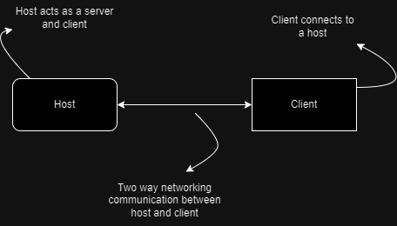

An increasingly complex but more scalable solution for networking following a client server model

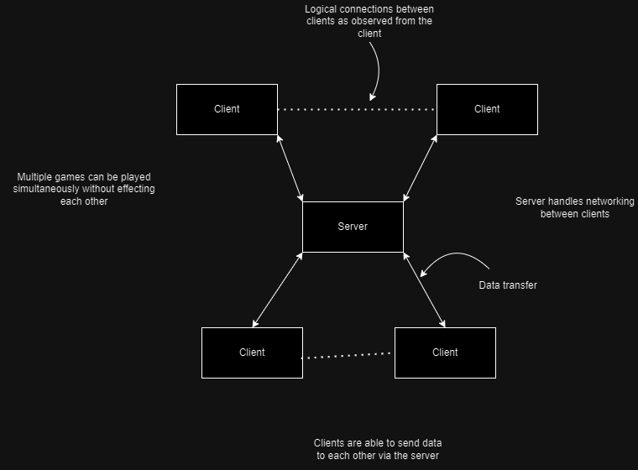

Input device to be used



Proposed game loop



Concept level for game made in unity engine (competitive mode)

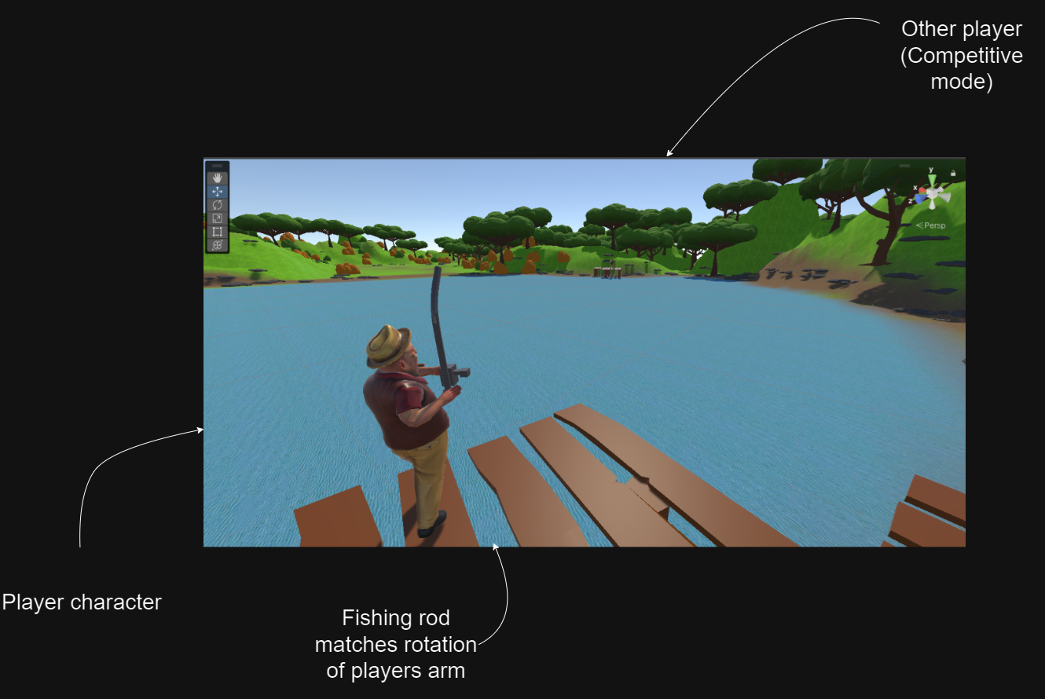

Concept level for game made in unity engine (collaborative mode)

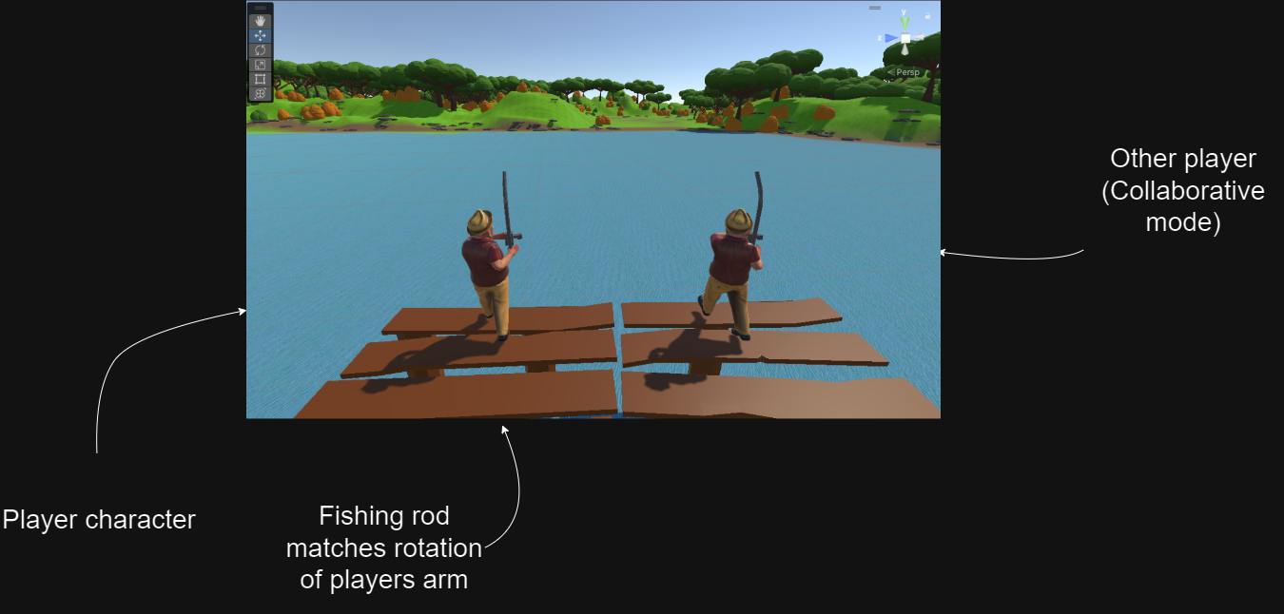

Player model sourced from Mixamo

# Method and Implementation

This section describes the development of the artefact, including design and implementation. This should reflect the progress made in the implementation along with feedback from your supervisor. This section is the first section of the assessment that is completely new to the report.

Remember that success of the project depends upon careful selection of appropriate method (e.g., design, model). A good method increases the validity and reliability of the outcomes. Depending on the type of project, it should cover the choice of apparatus, equipment, and software utilised. It should be possible for another researcher to repeat any experimental or research aspects of the project and expect to obtain the same data.

**In practice this section can be quite large and may often be broken into a number of additional sections, e.g., Methodology, Design, Implementation.** For practical, experimental and technical projects, there may be sections for calculations and analysis for parameterisation or model tuning as needed.

## Methodology

## Design

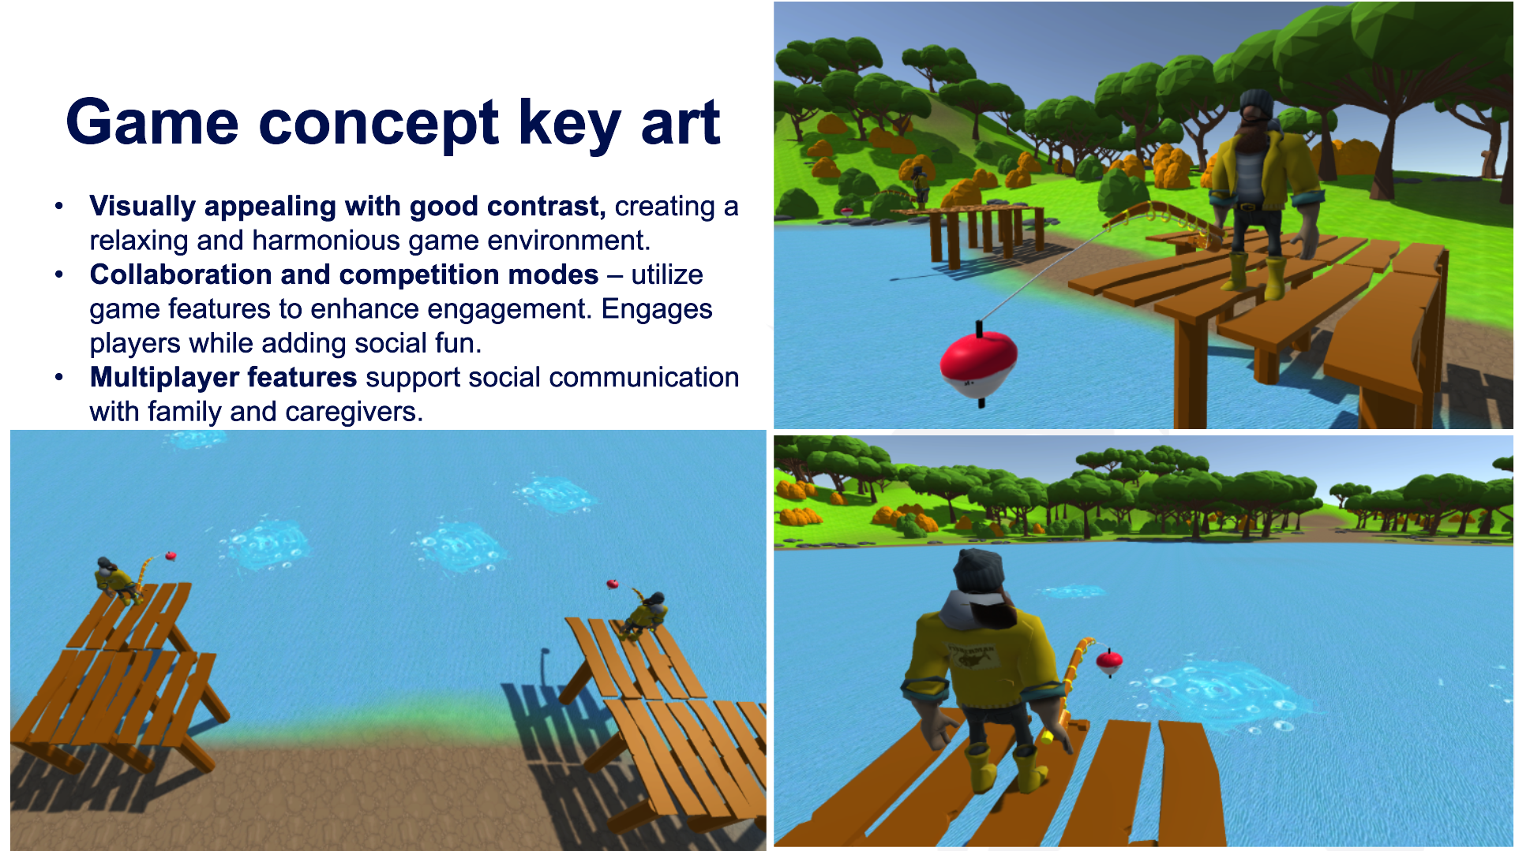

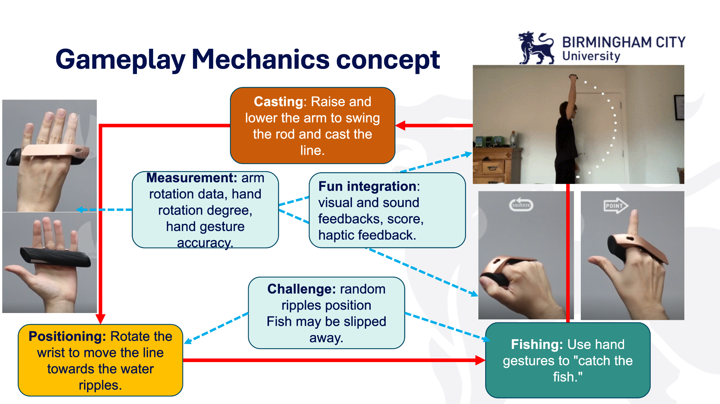

## Implementation

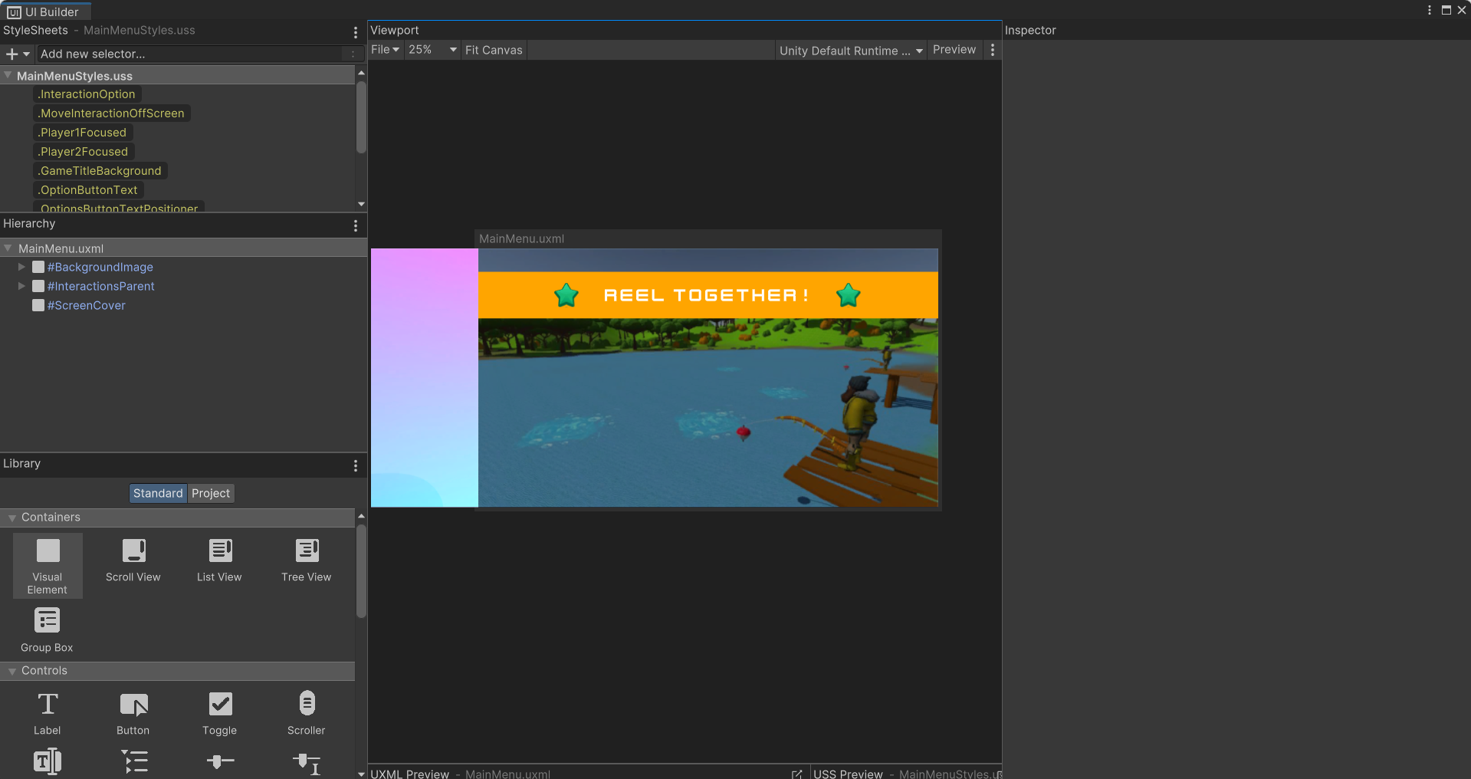

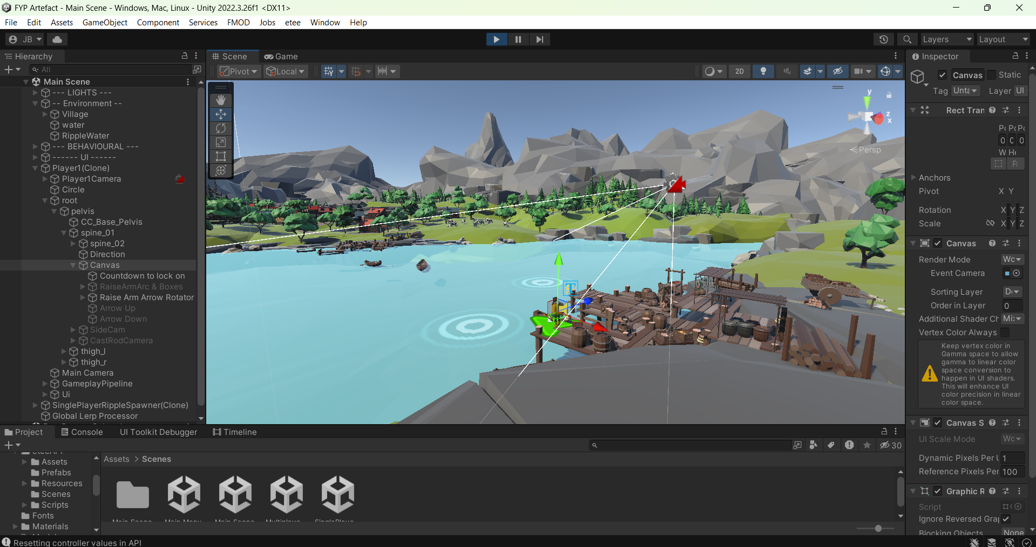

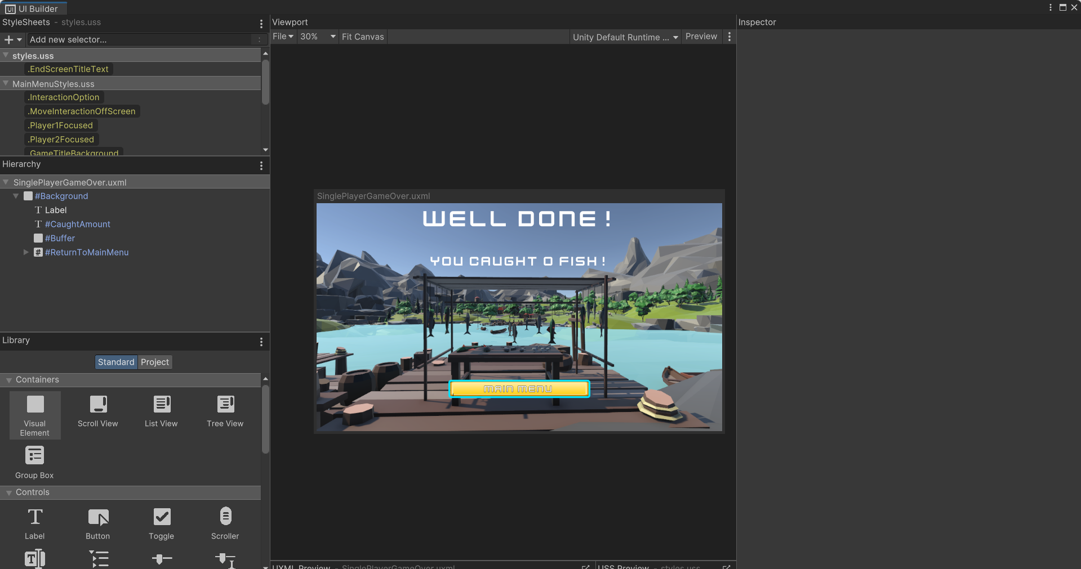

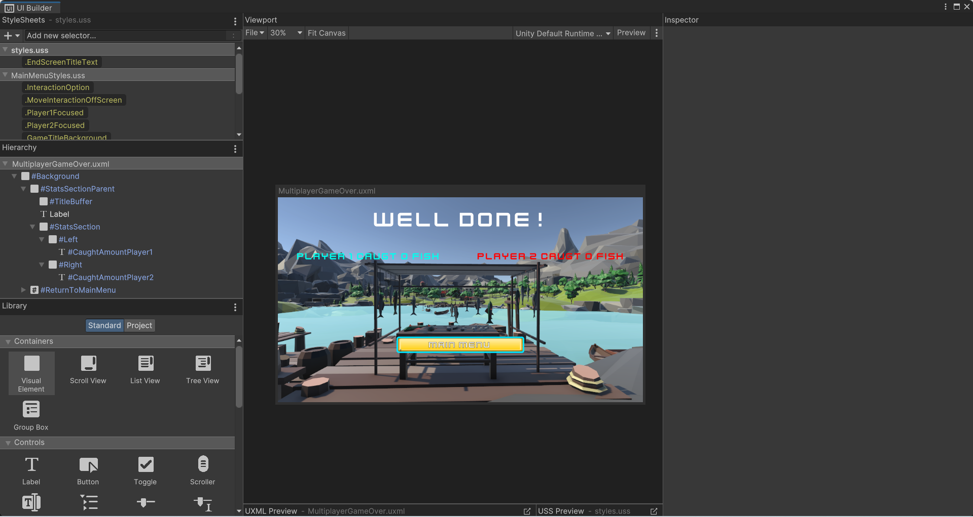

All details should be clearly presented no matter what section structure you have used.

# Evaluation

This section is the second section of the assessment that is completely new to the report.

GUESS - Phan, M.H., Keebler, J.R. and Chaparro, B.S., 2016. The development and validation of the game user experience satisfaction scale (GUESS). *Human factors*, *58*(8), pp.1217-1247.

SUS (as cited in) - Naturesa, F.T., Atika, R.D., Ayu, G.A. and Leandros, R., 2023, August. User Experience Evaluation on Nucleus Farma Website Using System Usability Scale. In *2023 International Conference on Information Management and Technology (ICIMTech)* (pp. 54-59). IEEE.

The evaluation section should provide testing of the artefact and overall project. This will express ideas in answer any research question. Depending on the evaluation chosen, a variety of possible layouts may result. Nonetheless, it is good practice to consider the evaluation section to be divided into two subsections based on the experimental design and the outcomes.

## Evaluation Methodology

Evaluation/Experimental methodology: Here you describe the selected approach to evaluating your design, as well as the motivation for the approach. If this is a standard way of measuring particular phenomena, then it can be motivated through citation. The experimental design of your evaluation will include various subsections possibly including:

**NB: The following sub-subsections (i.e., 4.1.1 through 4.1.3) may not be relevant to your specific project topics, so you should discuss the sections with your supervisor to tailor this to your needs.**

### Evaluation Metrics

The specific metrics being used to assess success.

### Baseline systems

Systems under analysis or Baseline systems: The designs being tested apart from the one proposed in the method section. Note that these may also be variants of the proposed approach.

### Dataset

A collection of data that is used to provide reliable consistency in comparative assessments across systems. Depending on your chosen project **this may or may not be relevant.**

## Results

**This section is mandatory.**

Here you will describe the detailed measurements of your system. Which trends appear? Which design performed best across which evaluations? If you have tables or figures that show the performance of your design (and possibly others) refer to these in the text as you explain the output. You may also wish to provide exemplar outputs of the design, which demonstrate the performance of your system, alongside a discussion of the result in the text.

## Discussion

This is a crucial section of the report and should be explored in great depth. The results from the previous subsection are here explained with consideration to the context of the project. This is the area in which you can confirm similarity or difference between trends that appear in your research with that of others that you have discussed in your literature review. You may also hypothesize why you believe certain outputs/phenomena have occurred. This is a deeper analysis in which you piece apart the results to determine the underlying causes of the recorded output.

For business and management related projects, the presentation of findings may be integrated within discussion sections. Limitations of the chosen methods should be identified and ways to overcome them suggested. If compromises have to be accepted, for example in time and cost. Such limitations and problems should be identified together with how they are to be overcome and/or the compromises that will have had to be made.

Depending on the nature of the project, and particularly with certain business topics for which the main outcomes are recommendations on various management related aspects, the results and discussion chapters may be integrated within chapter(s) of findings covering the relevant project objectives. In this case this chapter could be entitled Recommendations.

# Conclusions

The conclusions should be a short summary of the important results and findings arising from the results and discussion. It is important to ensure that the conclusions address the original project objectives and reflect the main discussion.

You should **not include any new information or discussion** in this section.

# Recommendations for future work

Many projects follow on from previous work and owing to time constraints and the generation of ideas whilst undertaking the work, lead on to the possibility of future work. These recommendations should be summarised briefly.

# References

It is essential that you reference and cite your work correctly. You should ensure all aspects of the project are underpinned by appropriate research cited in the body of the report. Full, correct and appropriate referencing of all sources used in undertaking the project is an essential requirement of a good report and necessary to avoid allegations of plagiarism. Harvard referencing must be used.

Use of, and reference to, a selection of relevant texts, journals and appropriate internet sources should enhance your work, reinforce the validity of your results and findings and demonstrate that you are familiar with accepted knowledge and thinking in the subject area. Reference sources should be selected to be comprehensive, appropriate and current. They should be well integrated with the text and cited in accordance with the University's standard (Harvard) method.

The [**library site provides extensive referencing information**](https://www.bcu.ac.uk/library/services-and-support/referencing).

**NB: Any use of sources that are not cited or cited incorrectly, may lead to allegations of plagiarism.**

# Bibliography

A bibliography is a list of relevant source texts you have used to undertake the project but not directly cited in the report, in Harvard format.

# Appendices

Appendices, which should have short titles, are separate documents appended at the end of the report. Only include appendices if they are necessary to explain particular details to understand the main report. **Generally, work in an appendix gains no marks directly.**

**You should include a copy of your Gantt chart in the Appendix.**

A report should flow freely and be easy to read. Figures, tables and images should support the content of the report not impinge on it. Do not place any information in the Appendices that can be located using a reference. The Appendix is not is not an opportunity to make a report look thicker. Do not include information that was not referred to in the report. Appendices do not have an introduction and begin with Appendix A if there are more than one. Otherwise, if there is only one, this is called ‘Appendix’. Appendices may include:

• Detailed statistics

• Computer code

• Large diagrams

• Complex graphs and tables

## Appendix A: Dissertation Style and Conventions

The report should be written in your own words and should not contain extended extracts from the work of others. It is possible to use direct quotes, but these must not account for more than 10% of your report. Direct quotes should be identified by using inverted commas and should be appropriately referenced. Additional resources to assist you with referencing can be found on the intranet homepage under Info Links.

The Faculty standard for degree project reports is similar to papers in technical/professional journals. Examples can be found by referring to journals in your field of study.

Producing a readable account requires a logical structure to lead the reader from one discussion point to the next and through from one section/chapter to the next. It also requires that care be taken in spelling, punctuation and grammar. Any significant errors are liable to cause a reader to suspect that the content of the report may also be flawed.

The language for the report should be straightforward jargon-free English, written in conventional style using the conventional third person past tense, and readable by someone familiar with the general subject area, although not an expert in the specific topic.

The following conventions should be used, and care should be taken to maintain a consistent style throughout the document.

## Appendix B: Fonts, Paragraphs and Line Spacing

Aim to maintain a consistent approach throughout. Use Arial font size 11. Use 1.5 line spacing between lines and double spacing between paragraphs (this is done automatically if using the ‘Normal’ style in this template). Do not indent at the start of a paragraph.

## Appendix C: Mathematical Symbols

Mathematical symbols and equations are best entered using a package (e.g., Equation Editor). Equations should be centred and numbered, with the numbers presented in parentheses in the right-hand margin. Additionally, all variables should be discussed in the text.

## Appendix D: Figure and Table Captions

When figures are referred to in the text they should written as: Figure 3.1 (i.e., with a space between Figure and the subsequent numbers), with the 3 denoting the chapter, and 1 denoting the number of the figure within the chapter. The word “Figure’’ should be written out completely (e.g., do not use “Fig”) in all instances of the word. As demonstrated in Figure 9.1, figure captions should appear centred below the figure, with the caption in lower case and an initial capital for first word and proper nouns only.

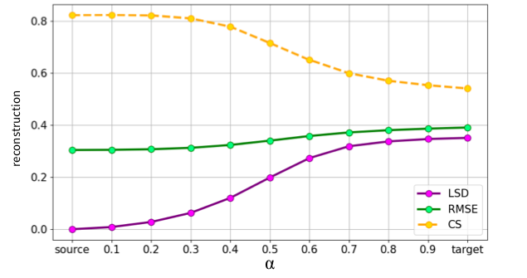

Figure 9.1: Reconstruction scores for interpolations between source and target rhythmic patterns. Results are calculated as a mean of 11000 transformations per each interpolated value of mixing parameter 𝛼.

When tables are referred to in text they should be written as: Table 9.1, (i.e., with a space between Table and the number subsequent numbers. Table headings should appear below the table. The table heading should be typed in the following way:

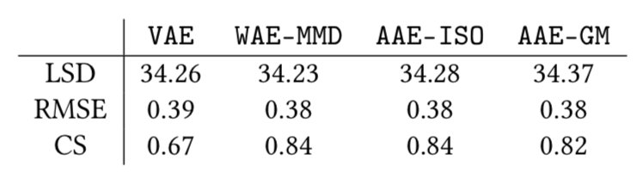

Table 9.1: Reconstruction scores (LSD, RMSE, CS) for three baseline models (VAE, WAE-MMD, AAE-ISO) and the proposed AAE-GM approach (Tomczak et al., 2020).

Additionally, if you are incorporating a figure or table from another source, you must cite the source as in the Table 9.1. Both tables and figures must have associated discussion in the text—they should not appear without reference, nor should they only be explained in the caption.

## Appendix E: Text Headings

Headings throughout the report should be consistent as follows:

Main sections and major headings should appear with initial capitals for first words and proper nouns. Leave a space of two lines above such headings and one below.

Section headings should be lower case with capital letters for the first letter of the first word and placed at the left-hand margin. Leave a space of two lines above such headings and one below. Subsection headings can be in italics, leaving a space above and below the heading. Section headers (e.g., 9.2) are available in the Styles Pane.

## Appendix F: Pagination

Starting on the Introduction page, pages should be numbered using decimal numerals (e.g., 1, 2, 3, 4). Pages prior to the Introduction page should have lower-case Roman numerals (e.g., i, ii, iii, iv).